**Unit Testing:**

Unit testing is the method which is checked whether the each and every control of the form are working or not. The given table used for unit testing shows the working of the different controls of various forms are success or failure.

**Login Form:**

|  |  |  |  |  |  |
| --- | --- | --- | --- | --- | --- |
| S.  N | Test  Description | Intended Result | | Actual Output | Action /  Remarks |
| 1. | Null Space  Validation | In case of blank field message should be displayed. | | The Login wasn’t successful in case of blank field. If username or  password wasn’t entered. | The test was successful. |
| 2. | Trying to access with wrong username and password | If the Login Username and  Password is wrong  the login shouldn’t be success. | | The Login wasn’t success in case of wrong username or password. | The test was successful. |
| 3. | The Login should be successful if correct user name and password is entered. | The login should provide access to main form after correct information was provided. | | The log in was successful after correct username and password was entered in textbox. | The test was successful. |
|  | | |  | | |
|  | | |  | | |

**Manage User:**

|  |  |  |  |  |
| --- | --- | --- | --- | --- |
| S.NO | Test  Description | Intended Result | Actual Output | Action/  Remarks |
| 1 | Null space validation | When any input field is left blank, adding user becomes unsuccessful. | Creating User was unsuccessful when any of the fields in the User form was left blank. | The null  validation  test was successful. |
| When all the fields are typed, the creating user was successful. | The creating user was successful when all the input fields were filled. |
| 2 | Password match confirm | When the characters of Password and Confirm Password, fields do not match then creating user was unsuccessful. | The Creating User was unsuccessful when the Password and Confirm password did not match showing error message as shown in figure. | The test was successful. |
| When Password and Confirm Password match, creating user becomes successful | The Creating user was successful when  Password and Confirm Password match as shown in figure. | The text was successful. |
| 3 | Duplicate  User Test | When same user name was entered then Error message should be shown. | The unsuccessful message was shown as there was already a same username. | The test was successful. |

|  |  |
| --- | --- |
|  |  |
|  |  |
|  |  |

**Manage Category:**

|  |  |  |  |  |
| --- | --- | --- | --- | --- |
| **S.NO** | **Test**  **Description** | **Intended output** | **Actual Output** | **Remarks /**  **Action** |
| 1 | Null space validation | When any input field is left blank, the process becomes unsuccessful. | The process was unsuccessful when any of the fields in the Category Form was left blank. | The null validation  test was successful. |
| When all the fields are filled, the process successes. | The process was successful when all the fields were filled. |
| 2 | Duplicate category testing | Repetition of Same Category Name is not allowed. | The process was unsuccessful when same category name was added. | The test result was  Successful. |

|  |  |
| --- | --- |
|  |  |
|  |  |

**Manage Product:**

|  |  |  |  |  |
| --- | --- | --- | --- | --- |
| **S.NO** | **Test**  **Description** | **Intended output** | **Actual Output** | **Remarks /**  **Action** |
| **1** | Null Space  Validation | When any input field is left blank, the  Process becomes unsuccessful. | The process was unsuccessful when fields were left blank in Product Form. | The null  Validation  test was successful. |
| **2** | Null Space  Validation | When all information was added then the process got success. | The process got success when all the input fields were filled. | The null  Validation  test was successful. |
| **3** | Duplication  Testing | When same product name was added the error, message should get displayed. | The process got success when same product name was tried get added. | The duplication testing was successful. |

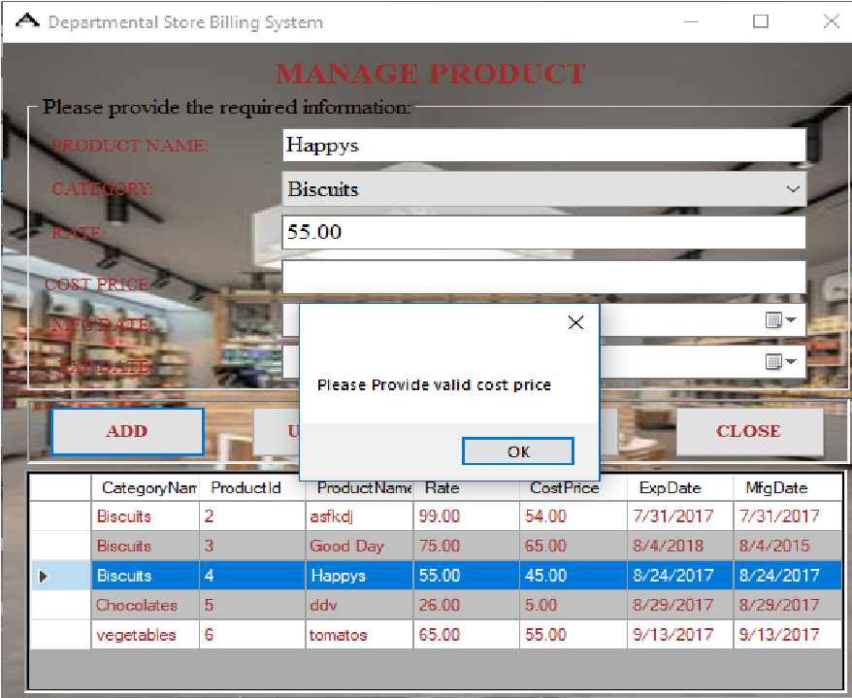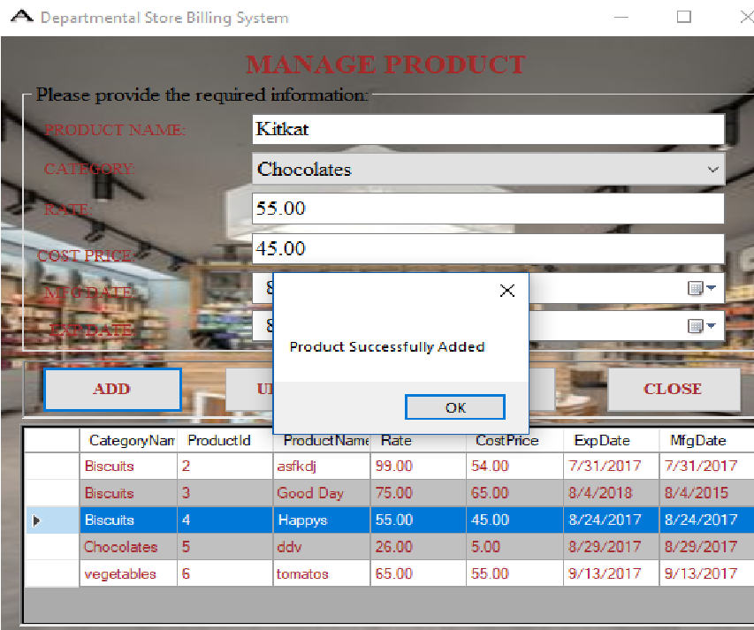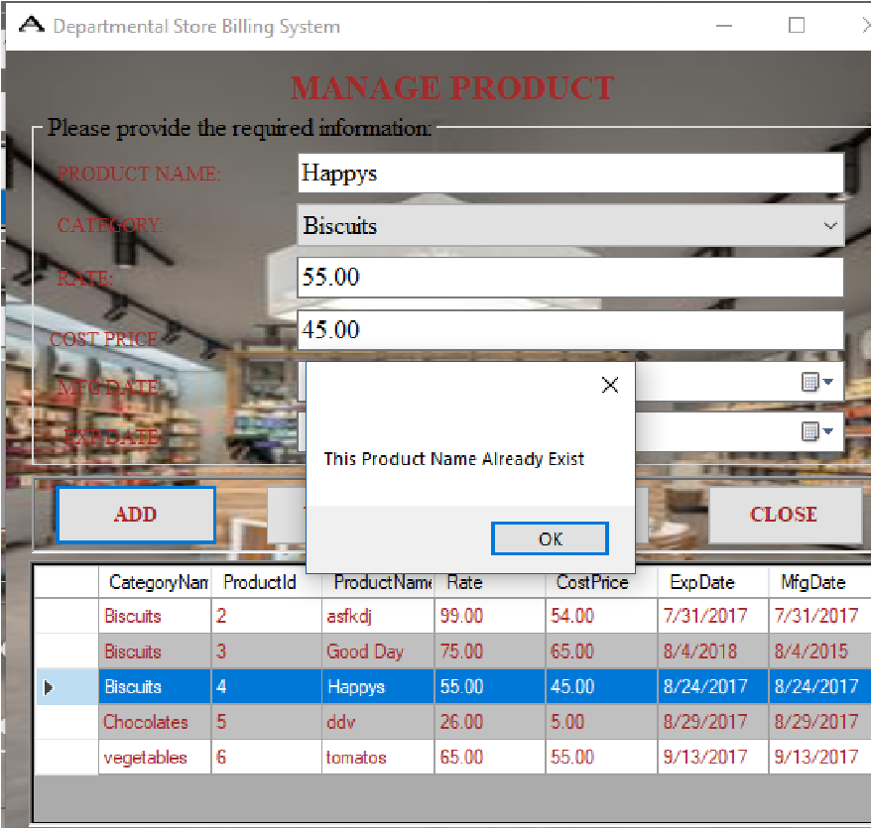

**Main Form:**

|  |  |  |  |  |
| --- | --- | --- | --- | --- |
| **S.NO** | **Test**  **Description** | **Intended output** | **Actual Output** | **Remarks /**  **Action** |
| **1** | Null Space  Validation | When any input field is left blank, the  Process becomes unsuccessful in  Invoice  Generation Section. | The process was successful when fields were left blank in Invoice Generation. | The null  Validation test was not successful. |
| **2** | Null Space  Validation | When all information was added then the process got success. | The process got success when all the input fields were filled. | The null  Validation  test was successful. |
| **3** | Duplication  Testing | When blank order was tried to receive then the error message should arrive. | The process got success when null order was tried to receive. | The null  Validation  test was successful. |

|  |  |
| --- | --- |
|  |  |
|  |  |

**Integrated Testing:**

For checking the proper working of the save, update and delete buttons which is used in the form is done through integrated testing. The given table shows success or failure of the integration testing done from project.

**Manage User Form:**

|  |  |  |  |  |
| --- | --- | --- | --- | --- |
| **S.NO** | **Test**  **Description** | **Intended output** | **Actual Output** | **Action /**  **Remarks** |
| 1 | The working of Add button | After clicked on save button, User need to be added and saved in the database. | As per expected result User is added and saved in the database. | The test was successful. |
| 2 | The working of Update button | After clicked on update button, User need to be updated. | As per expected result User is updated. | The test result was successful. |
| 3 | The working of Delete button | After clicked on delete button, User need to be deleted. | As per expected result User deleted. | The test result was successful. |

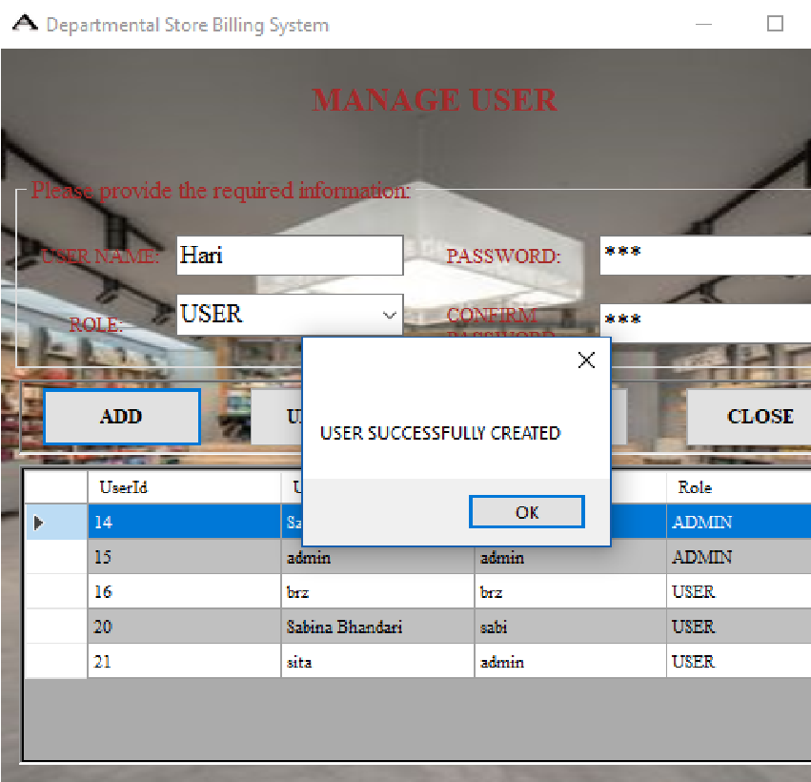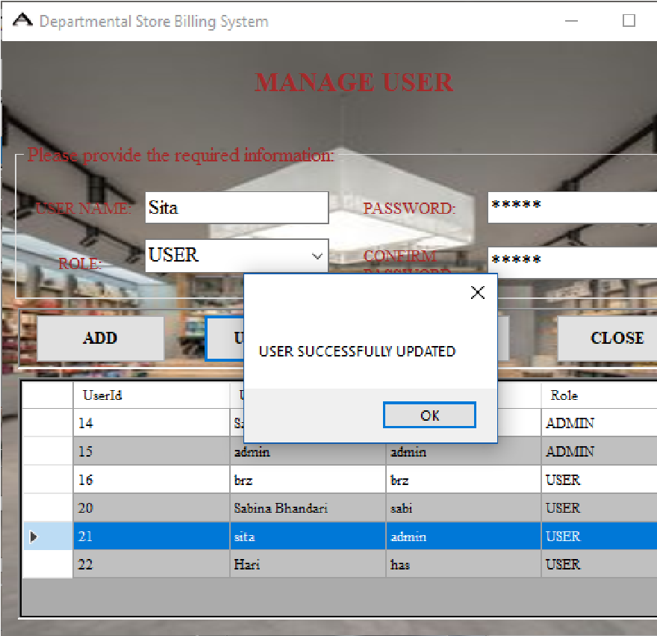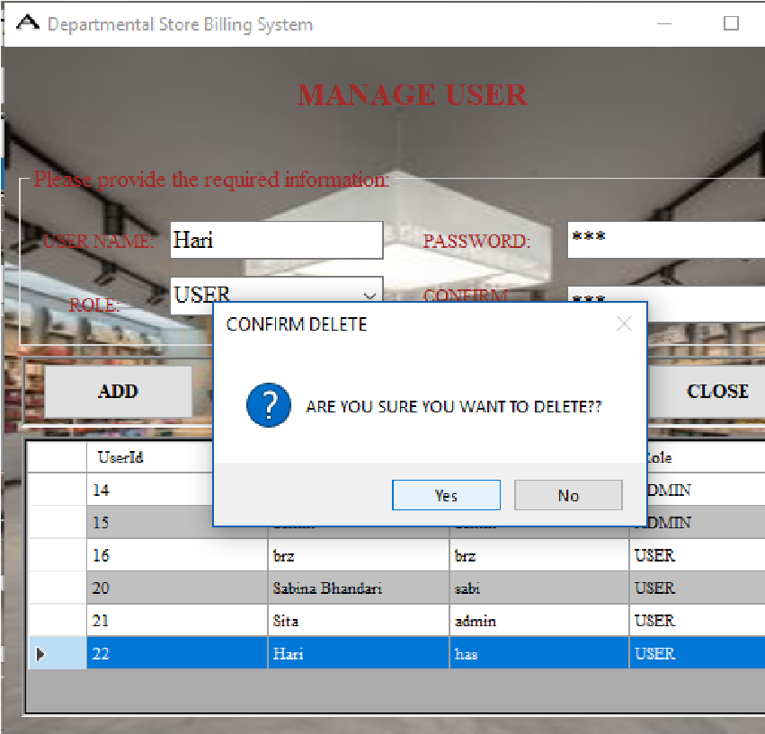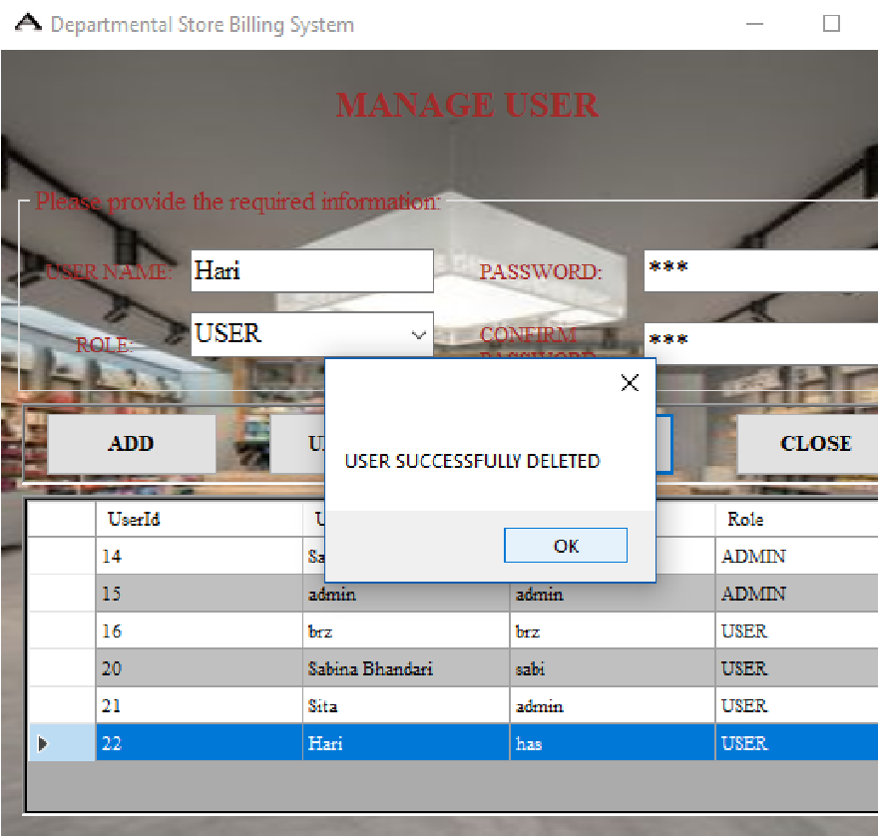

**Integrated Testing of Manage Category Form:**

|  |  |  |  |  |  |
| --- | --- | --- | --- | --- | --- |
| S.  N | Test Description | Intended  Output | Actual Output | Action  Remarks | / |
| 1. | The working of  Add button | After clicked on save button, Category need to be added and saved in the database. | As per expected result  Category is added and saved in the database. | Tested successfully. |  |
| 2. | The working of  Update button | After clicked on update button, Category need to be updated. | As per expected result  Category is updated. | Tested successfully. |  |
| 3. | The working of  Delete button | After clicked on delete button, Category need to be deleted. | As per expected result Category deleted. | Tested successfully. |  |

|  |  |
| --- | --- |
|  |  |
|  |  |

**Integrated Testing for Manage Product:**

|  |  |  |  |  |  |
| --- | --- | --- | --- | --- | --- |
| S.  N | Test Description | Intended  Output | Actual Output | Action  Remarks | / |
| 1. | The working of  Add button | After clicked on save button, Product need to be added and saved in the database. | As per expected result  Product is added and saved in the database. | Tested successfully. |  |
| 2. | The working of  Update button | After clicked on update button, Product need to be updated. | As per expected result  Product is updated. | Tested successfully. | |
| 3. | The working of  Delete button | After clicked on delete button, Product need to be deleted. | As per expected result Product deleted. | Tested successfully. | |

|  |  |
| --- | --- |
|  |  |
|  |  |

**Stress Testing:**

Whenever we need to find the controls on the forms to accept the criteria other than mentioned or made limited is done through stress testing. In the given table stress testing shows the success and failure test of the project.

**Stress Testing for User Form:**

|  |  |  |  |  |  |  |
| --- | --- | --- | --- | --- | --- | --- |
| S.  N | Test Description |  | Intended  Output | Actual Output | Remarks  Action | / |
| 1. | Maximum characters User Name. | in | After adding more characters on user name of user form, error need to be created. | As per expected result error is occurred in user form with maximum  characters used in user name. | Tested successful. |  |

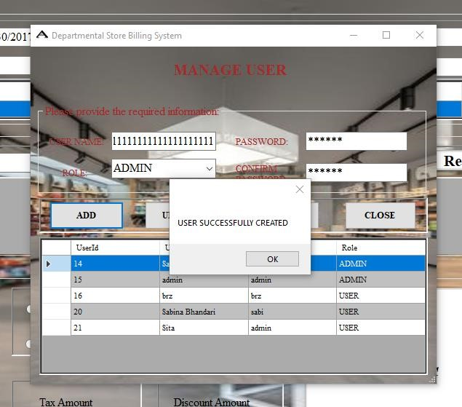

**Stress Testing for Category Form:**

|  |  |  |  |  |  |
| --- | --- | --- | --- | --- | --- |
| S.  N | Test Description | Intended  Result | Actual Output | Remarks  Actions | / |
| 1. | Maximum characters in Category name. | After adding more characters on Category name of Category form, error need to be created. | As per expected result error is occurred in Category form with maximum characters used in Category name. | Tested successful. |  |

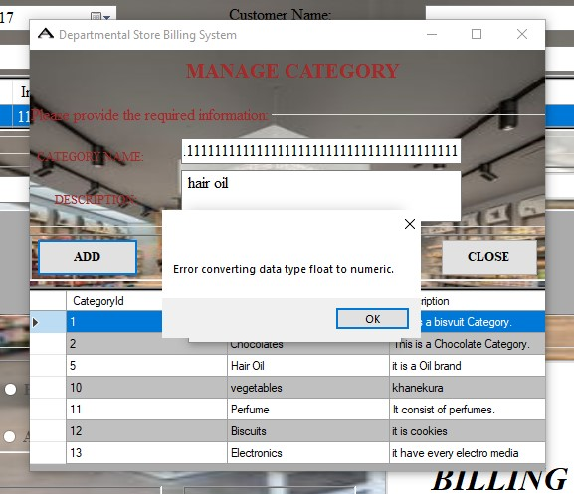

**Stress Testing for Product Form:**

|  |  |  |  |  |  |
| --- | --- | --- | --- | --- | --- |
| S.  N | Test Description | Intended  Result | Actual Output | Remarks  Actions | / |

|  |  |  |  |  |
| --- | --- | --- | --- | --- |
| 1. | Maximum characters in Product name. | After adding more characters on Product name of Product form, error need to be created. | As per expected result error is occurred in Product form with maximum characters used in Product name. | Tested successfully. |
| 2. | Maximum characters in  Rate. | After adding more characters on rate of Product form, error need to be created. | As per expected result error is occurred in Product form with maximum characters used in Rate. | Tested successfully. |
| 3. | Maximum characters in  Cost Price. | After adding more characters on Cost Price of Product form, error need to be created. | As per expected result error is occurred in Product form with maximum characters used in Cost Price. | Tested successfully. |
| 4. | Cost Price Stress | Error should occur when the Cost Price was given with other than integer value. | Error Message should be shown in both cases. | Tested successfully. |
|  |  | Error should occur when input Cost  price exceeds  18 integer values. |  |  |
| 5. | Rate Stress | Error should occur when the Rate was given with other than integer value. | Error should be shown in both the cases. | Tested successfully. |
| Error should occur when input rate  exceeds 18 integer values. |

